**Setting up AWS EC2 Instance**

1. Log in to AWS console <https://aws.amazon.com/>
2. Search for EC2 Service

1. Click on Instances in the Left pane.
2. Click on Launch Instance

1. Enter Name (prefix with your first name), AMI as Ubuntu

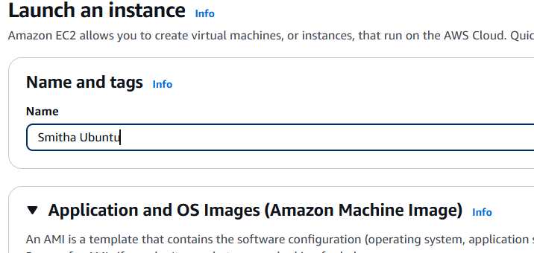

1. Keep Instance Type as t2.micro.

1. Select Create a New Key pair, give a name, select .ppk as format and download the key file

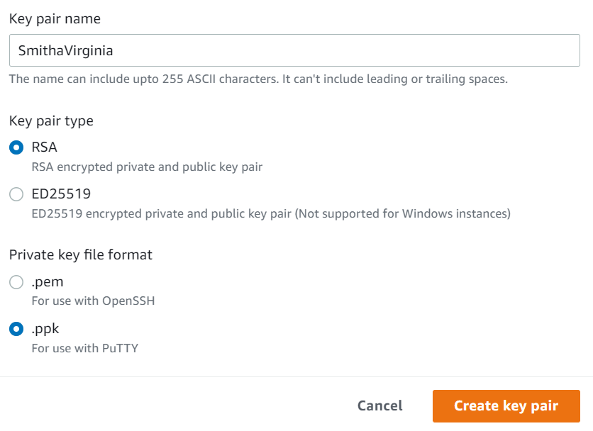



1. Select the newly created Key from the list. Then in Network settings, enable HTTP traffic.

1. Click Launch Instance

1. Go to Instances, Once the instance is running, Select the instance.

1. Note down the ip address.

1. Connect to the instance using putty.exe.

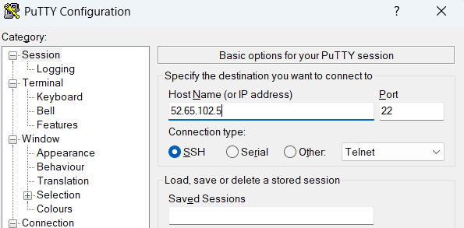

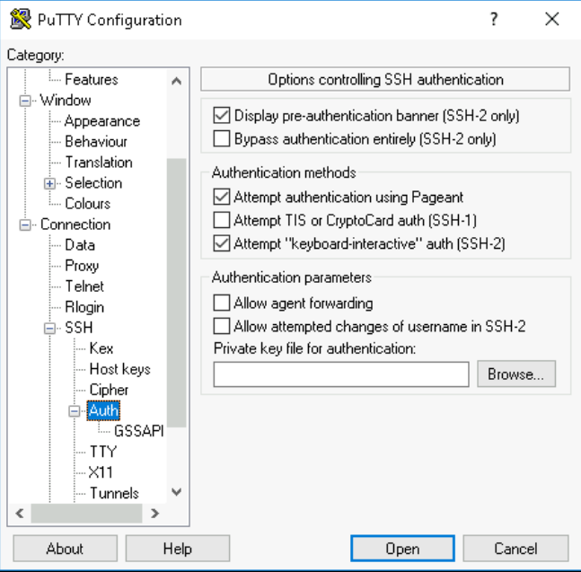

1. Run the following command to update the ubuntu repository list.

sudo apt update

sudo apt install apache2 -y

curl localhost